1,
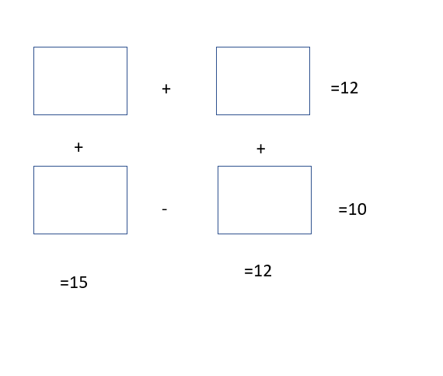
2.5
12.5
9.5
2.5

2,
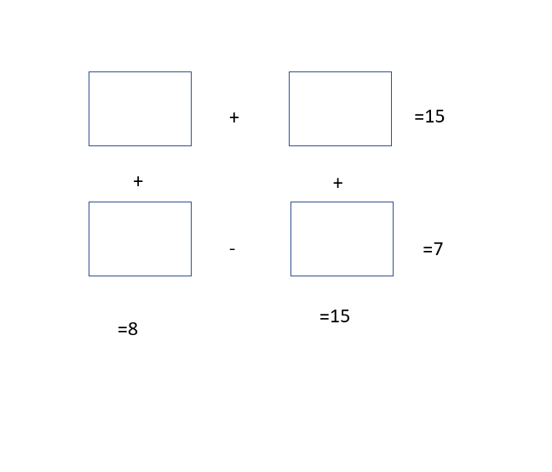
0.5
7.5
14.5
0.5
3,
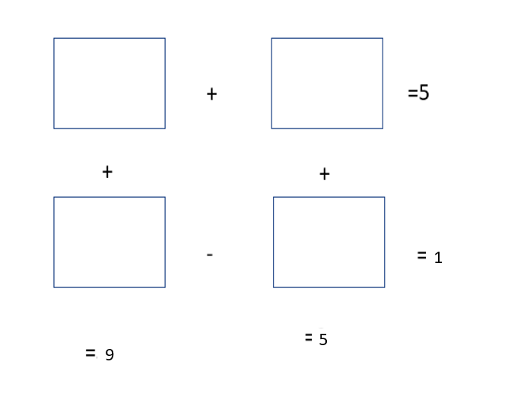
4
1
5
4
4,
1 , 2 , 4 , 8 ,16,32, 64
1, 4 , 16 ,64, 256, 1024

